***drawer***

by CDJR technologies

**Final Project Report**

**INFO30005**

**Introduction & Background**

**Our challenge**

‘How might we inspire young people to cultivate their creative confidence?’

**Why we chose this challenge**

While we considered several of the challenges from the OpenIDEO website, we ultimately settled on this one for two main reasons:

Firstly, we felt that this was a challenge that we could realistically help solve by creating a website. Although we found that many of the OpenIDEO challenges like ‘accelerating immunisation coverage for rapid urbanisation’ were both interesting and important, they generally seemed to fall outside the scope of what a single website could achieve. The challenge of ‘cultivating creative confidence’ is a personal and social problem, and thus one that can be tackled more readily through the implementation of a simple platform based website. It was simple enough for us to build a viable solution within the timeframe of a semester, but also complex enough for us to have room to come up with creative solutions to the problem.

Secondly, we are ourselves passionate about art, creativity and design. In our spare time we like to draw and create things, and so we saw our potential solution to this challenge as something that we could and would use ourselves. Moreover, much of the web information technologies project is fundamentally based on creativity and design, and so we saw this challenge as a perfect match for what we wanted to achieve with the project.

**Why this challenge is important**

For this to be a meaningful project, we had to make sure that our chosen topic was also a meaningful challenge. As we began our initial research process, it quickly became clear that ‘inspiring creative confidence’ amongst young people is a critical task that has far reaching implications in the fields of education, the arts and innovation as a whole. For example, a study by Throsby and Zednik (2010) estimates that a third of artists bring their creative skills to other industries, while a study by Runco (1991) found that training in creative thinking leads to better problem solving and creativity amongst young children. Even from individual intuition and experience alone, it is clear that many of the things that we personally find to be inspiring, exciting and joy-inducing in life are the products of creative work. To inspire creative confidence amongst young people is a challenge that could have a positive effect on society as a whole, and thus also a challenge that we believe is worth pursuing.

**Design Process**

**Stage I - examining current solutions**

We began the design process by assessing the main art-sharing websites that are popular in 2019. There are three websites that we will discuss in the following section: flickr, instagram and deviantart.

**Flickr**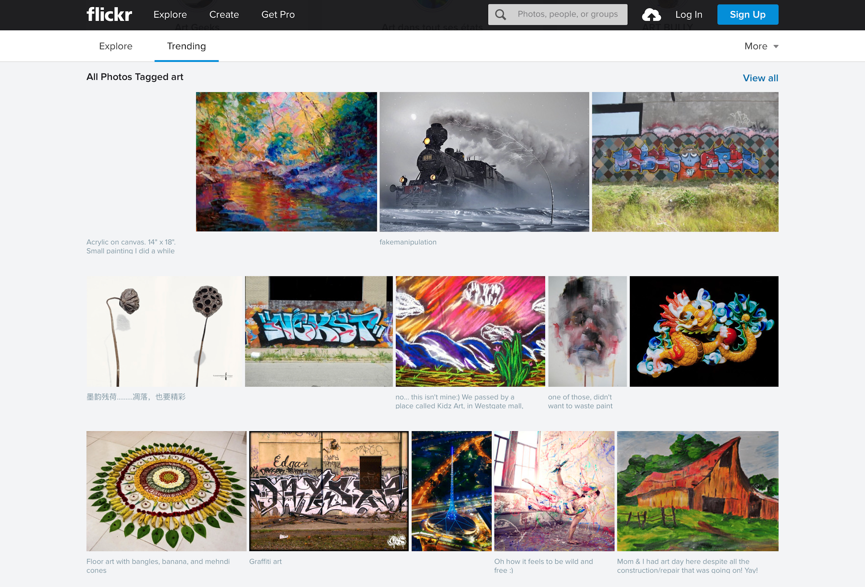

Flickr is a popular photo sharing website that many artists use to exhibit their art. While the website has a clean design and some good features like the ability to add comments directly onto specific parts of a photo, it isn’t necessarily the best place to find ‘creative confidence’ because of the way it highlights only the best works. To an amateur artist, going on flickr can be potentially intimidating rather than inspiring. We believe that a good art sharing website needs to not only highlight amazing artwork, but also the individual journeys of the artist and how they have progressed over time to be able to produce those works in the first place. This is something that flickr fundamentally lacks.

**Deviantart**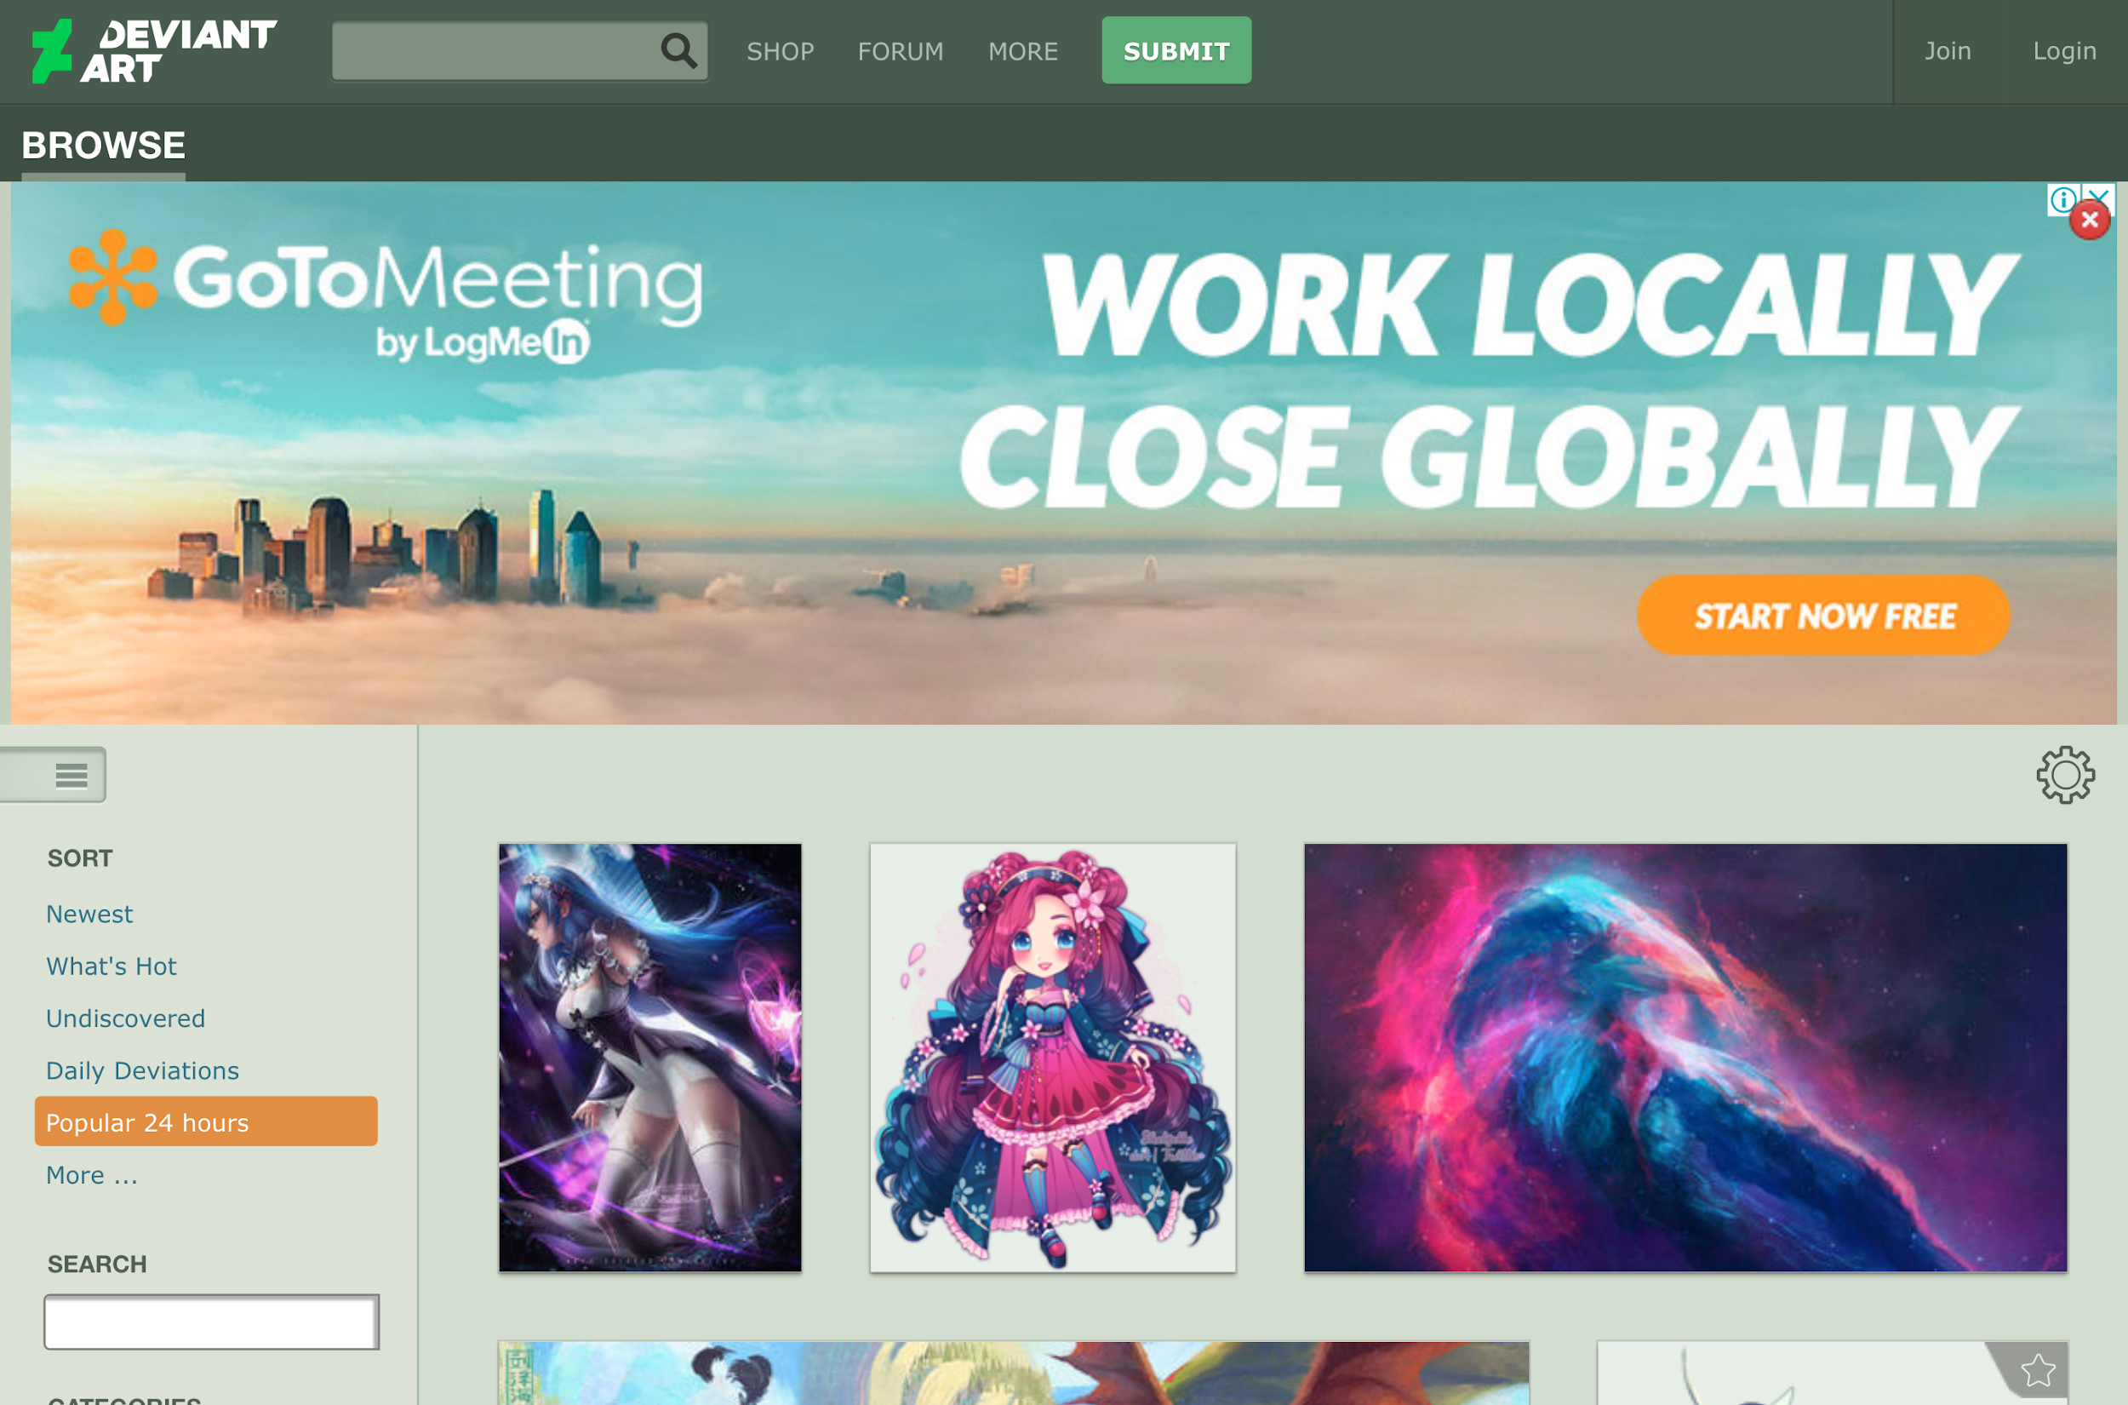

Deviantart is the only website on this list that is specifically tailored to the art community. We see two major flaws with deviantart - first, its community and artists are too niche, and a lot of the content on the website is somewhat questionable (eg. overly sexualised cartoons), and second, like flickr it lacks a sense of ‘artist progression’. These two simple reasons make it clear that deviantart does not solve the problem that we want to solve.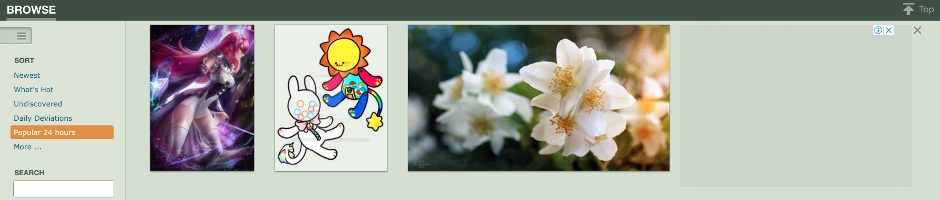

**Instagram**

Instagram is easily the most popular website that we assessed, with over 1 billion monthly users. While it has a strong user experience, this experience isn’t art focused, and again only tends to focus on trending works of high quality, so like deviantart and flickr there is no focus on artist progression. Moreover, instagram contains too much other content like influencers, models and other enthusiast pages for it to be considered as a true art sharing website. A user on instagram is likely to end up viewing a lot of content that isn’t art related at all, and thus we also don’t consider it as a true solution to inspiring creative confidence.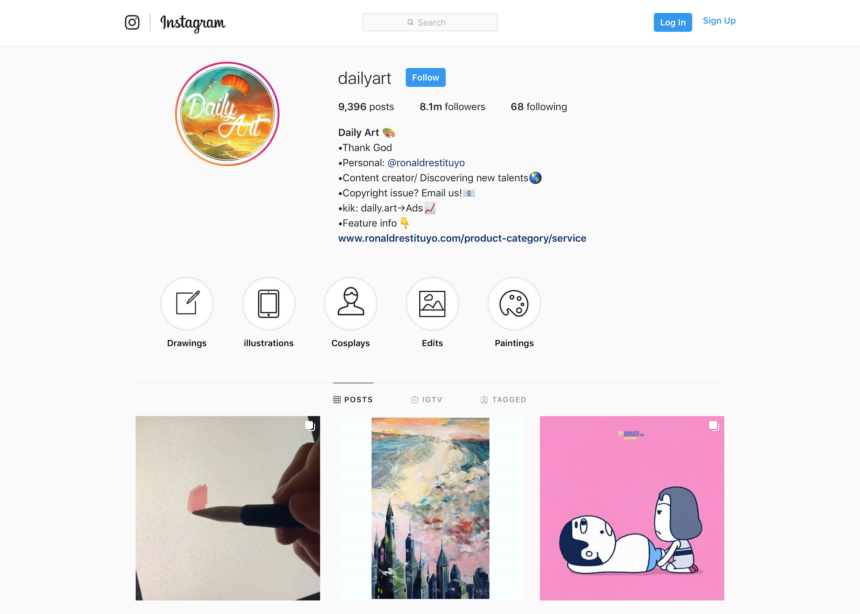

**Stage II - mockups**

Once we had assessed the existing potential solutions on the market, we got to work brainstorming ideas for our own website. The main thing that we wanted to ensure that we had was the ability to see the overall journey of progress for any individual artist. This was something that we felt that all of the websites that we looked at lacked, despite it being a core part of inspiring creative confidence (since it allows amatuer artists to understand at a deep level that everyone starts with little skill). During this stage we also came up with the name ‘drawer’ for the website. ‘Drawer’ is supposed to have two interpretations - it is a direct reference to our potential user base (people who like to draw), and it is also a reference to the idea that our website is a place to store past art (like a physical drawer).

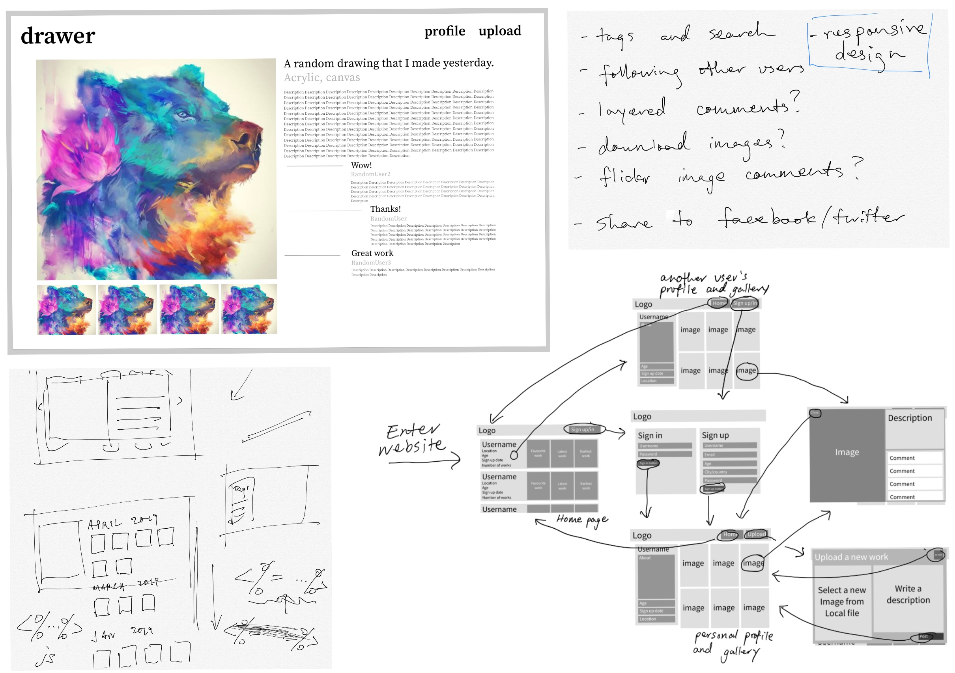

We started off by drawing rough sketches of the potential website design, which allowed us to have in depth discussions about how we wanted it to function and look (bottom left image). Next, we narrowed down exactly which features we wanted to try to build into the website alongside the ‘artist progression’ feature (top right image). Once this was completed, we got to work formalising the design of our website, and created a functionality map that we could reference during the rest of the development process (bottom right image). This map aided us immensely when the time came to divide our roles and responsibilities. Finally, we created some basic aesthetic mockups (top left image) to help guide the direction of our frontend design.

**Stage III - interviews**

In the final stage of our design process, we interviewed friends, fellow artists and classmates to assess the effectiveness of our planned solution. This was achieved by presenting them with our functionality map, and walking them through the website’s various use case scenarios. By doing this, we gained valuable feedback on what features our users wanted and didn’t want, as well as some helpful ideas for further exploration. One thing that became clear from our interviews was that our potential users all really wanted some sort of search or tagging feature to organise art, which was something that we were considering but weren’t sure about including. In this way, the interviewing process helped to inform our decision making during the design process, and our findings from this stage are reflected deeply within the design of the final website itself.

**Development Process**

**Allocating roles and responsibilities**

When the time came for us to begin development in earnest, we began by first clearly dividing up our roles and responsibilities. In accordance to each group member’s interests and prior experience, we split the workload as fairly and evenly as possible. In the end, it was decided that Dongdong would work on the website’s ‘skeleton’, setting up much of the backend infrastructure, Cheng would focus on the website’s home page and video production, Rowan would work on setting up the website’s image storage functionality, and Jerome would do much of the front end design, as well as implement the search and sorting functions.

While the official subject deliverables seemed to suggest that we work together on each stage of the project together, we decided from the beginning that we would mostly ignore the subject’s suggested timeline and work ahead of it. Instead of working on every single feature together as a group, we mostly worked independently, discussing our progress with one another during weekly meetings. This allowed us to stay well ahead of the submission dates for each deliverable, and made development a smooth and stress free process. By the final few weeks of the semester, all that we had to do was integrate our work and make the user interface consistent across different pages, a task made easy through our reliance on git.

**Tools and frameworks**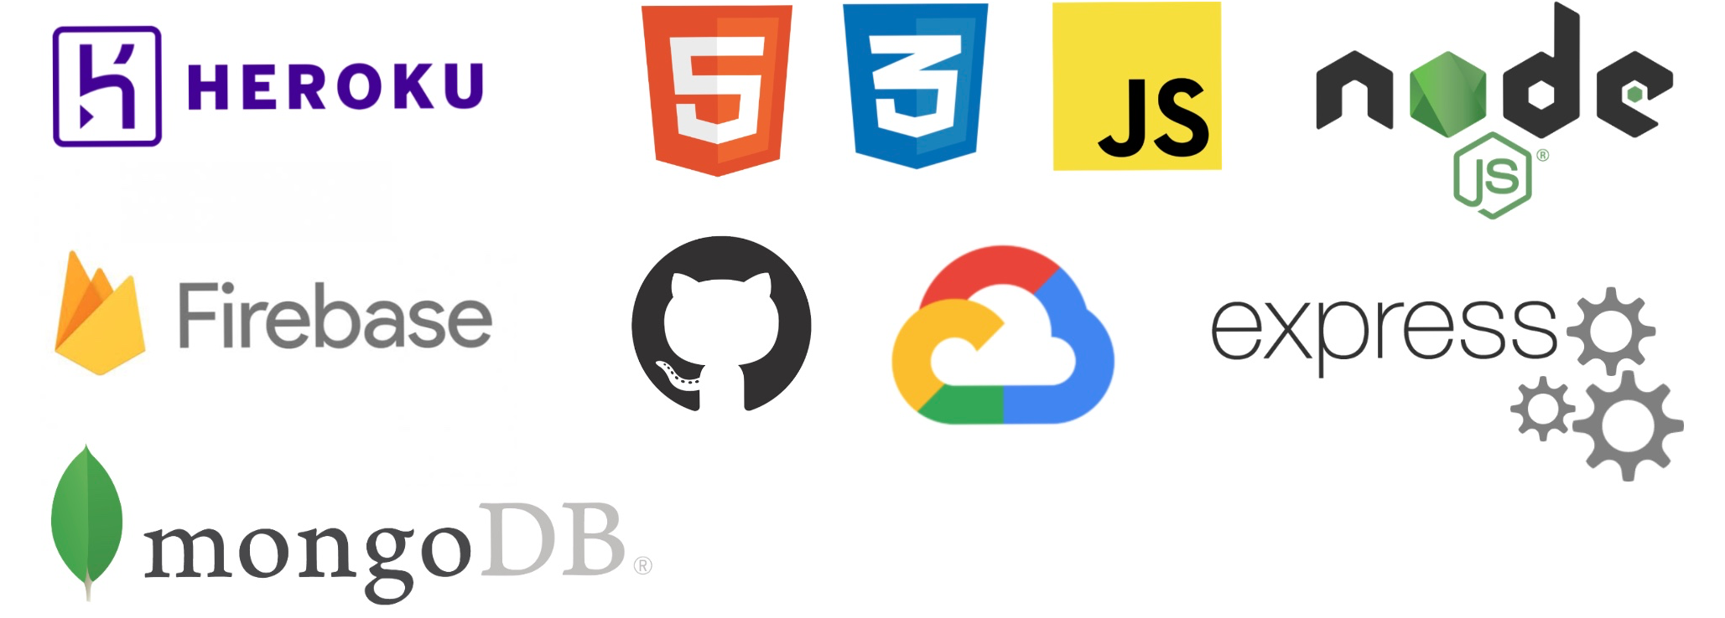

Asides from allocating roles and responsibilities, one of the first things that we did during the development process was determine our tech stack. For the most part these were easy decisions to make as we were limited by the requirements of the subject - node.js and express were chosen for the backend API, mongoDB was chosen to store data, html and css were used for front end presentation, js was used for behaviour, heroku was chosen for hosting, and github was chosen for git and collaboration.

In addition to the subject’s required tools and frameworks, we also used a few of our own. We chose firebase to store the image data (because MongoDB has a 16mb document size limit), Google Cloud Platform’s Vision API for automated image tagging and ejs (embedded javascript) to make some of the development simpler and faster. In addition, we occasionally relied on bootstrap for fast prototyping and occasional templating. Finally, we used Slack extensively for group communication.

**Repository management**

To easily collaborate, we relied on github for this project. Because of the way we allocated roles and responsibilities, repository management was quite straightforward as there were rarely any conflicts. Each of us worked with a private branch during development, and then met up to merge our branches into the master branch and solve potential conflicts once we were ready.

**System Description**

The following section will present each of Drawer’s core functionalities, discussing what it achieves and why.

**Home Page**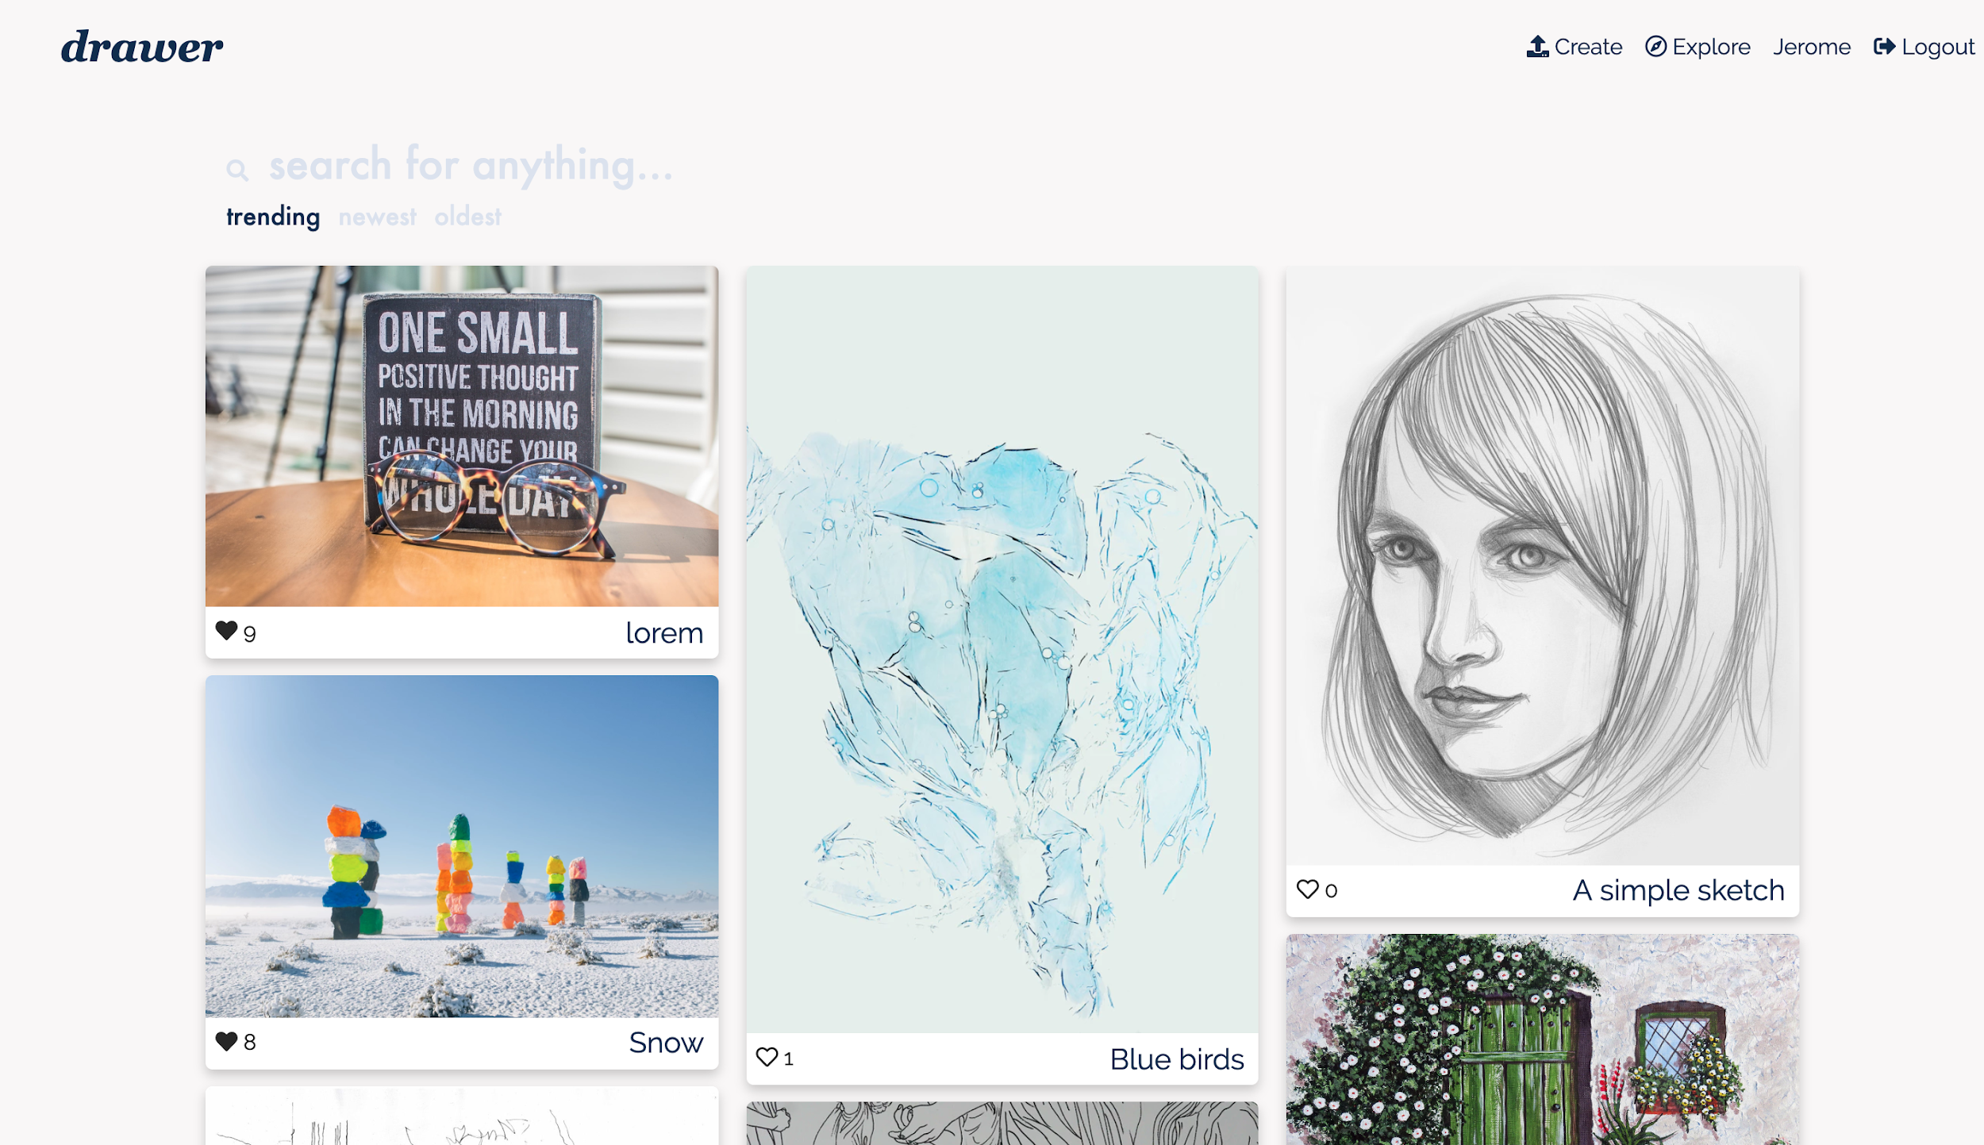

Drawer’s homepage displays a gallery of all user works, sorted by likes or upload date. In this sense it is quite similar to existing websites like flickr and deviantart, since the focus here is on highlights from across the website. For users, the homepage is a place to explore and discover new artists and their artwork. Users can also favourite artworks from this page by giving out likes!

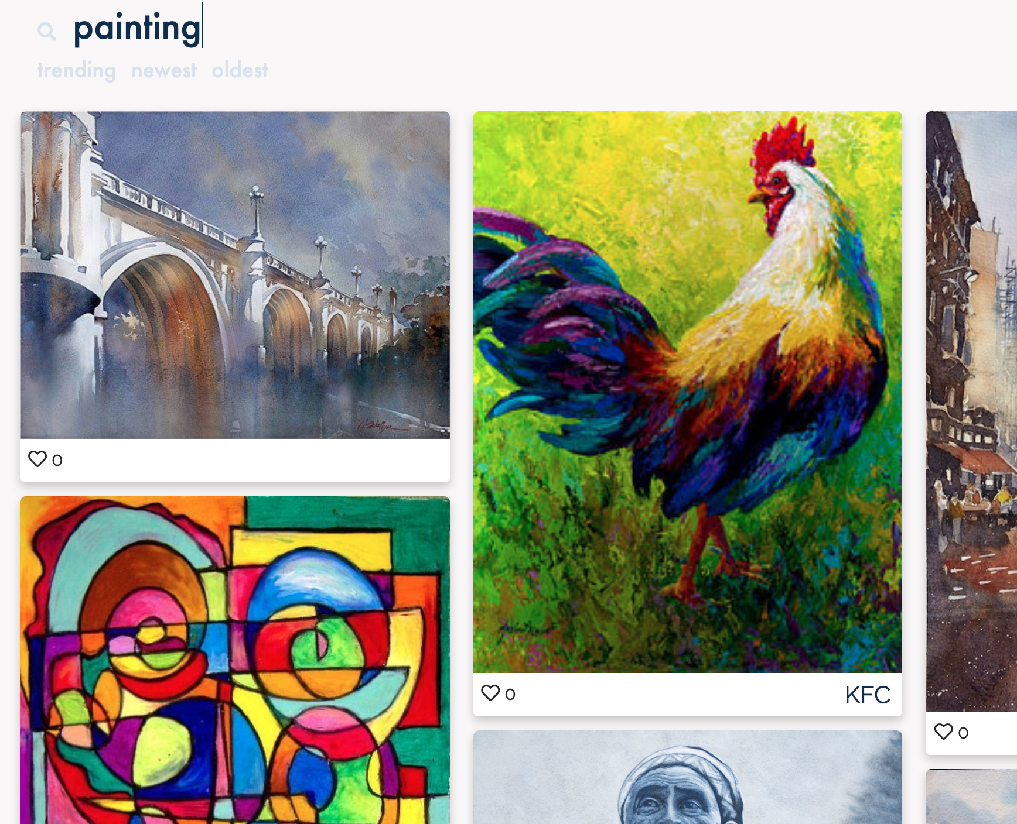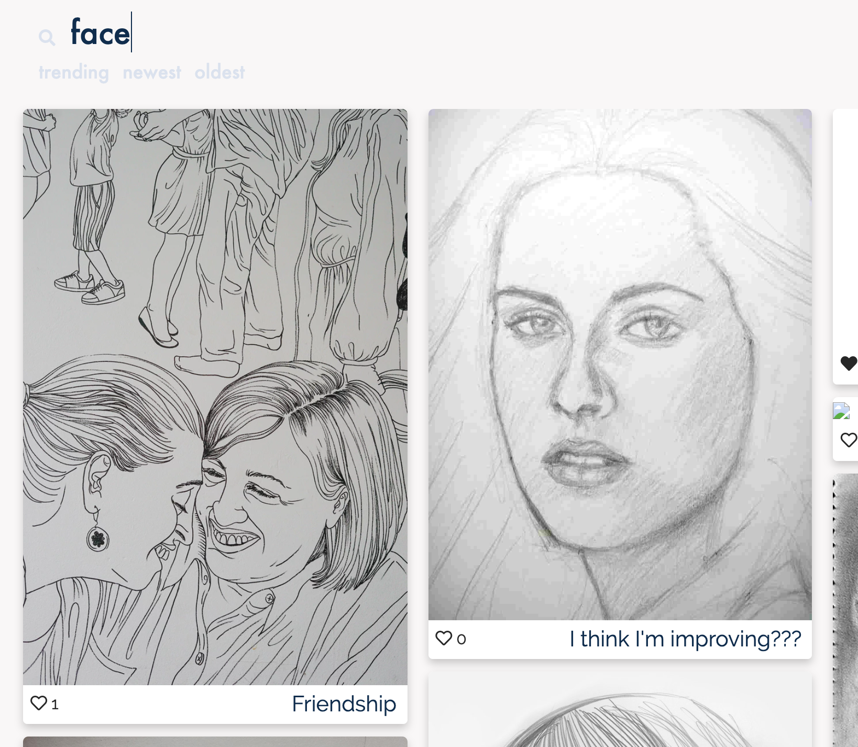

What sets our homepage apart from other websites is its advanced search features. Powered by Google Cloud Platform’s Vision API, images that are uploaded to drawer are automatically tagged according to their content. This allows us to create a search function where users can not only search by username and title, but also by an artwork’s medium and even what it is depicting!

**Profile page**

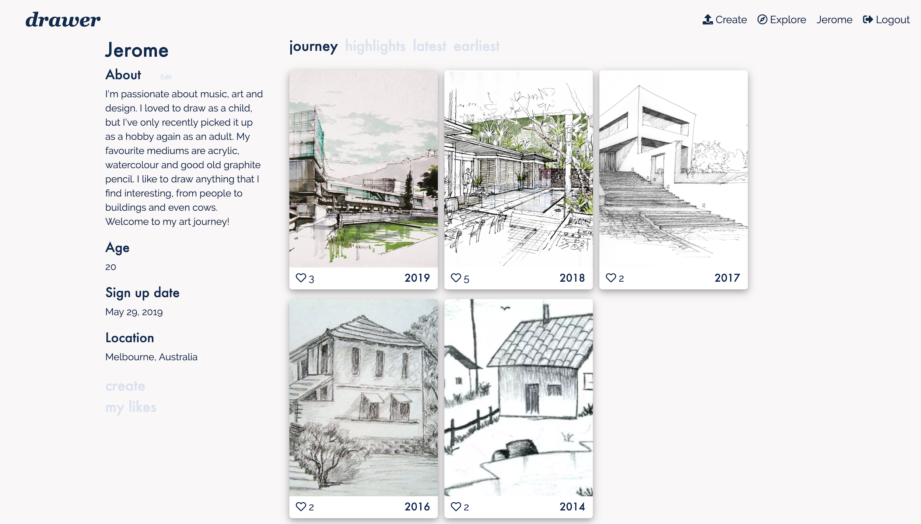

The profile page is what makes drawer special. Here, artists can share their artworks and their journey of progress in a clearer, more intuitive way than any other website. Crucially, users viewing an artist’s profile can choose how they want to view their work - either as a ‘journey’ of yearly highlights, a complete gallery sorted by number of likes, or a complete gallery sorted by upload dates. By default we enable the ‘journey’ sorting method, which we hope will make it clear to all users that mastery and skill come at the cost of time and practice. By doing so, the profile enables creative confidence, as it steps away from only highlighting the most amazing artists and ignoring the context of an individual artist’s journey of gradual progress.

**Viewing art**

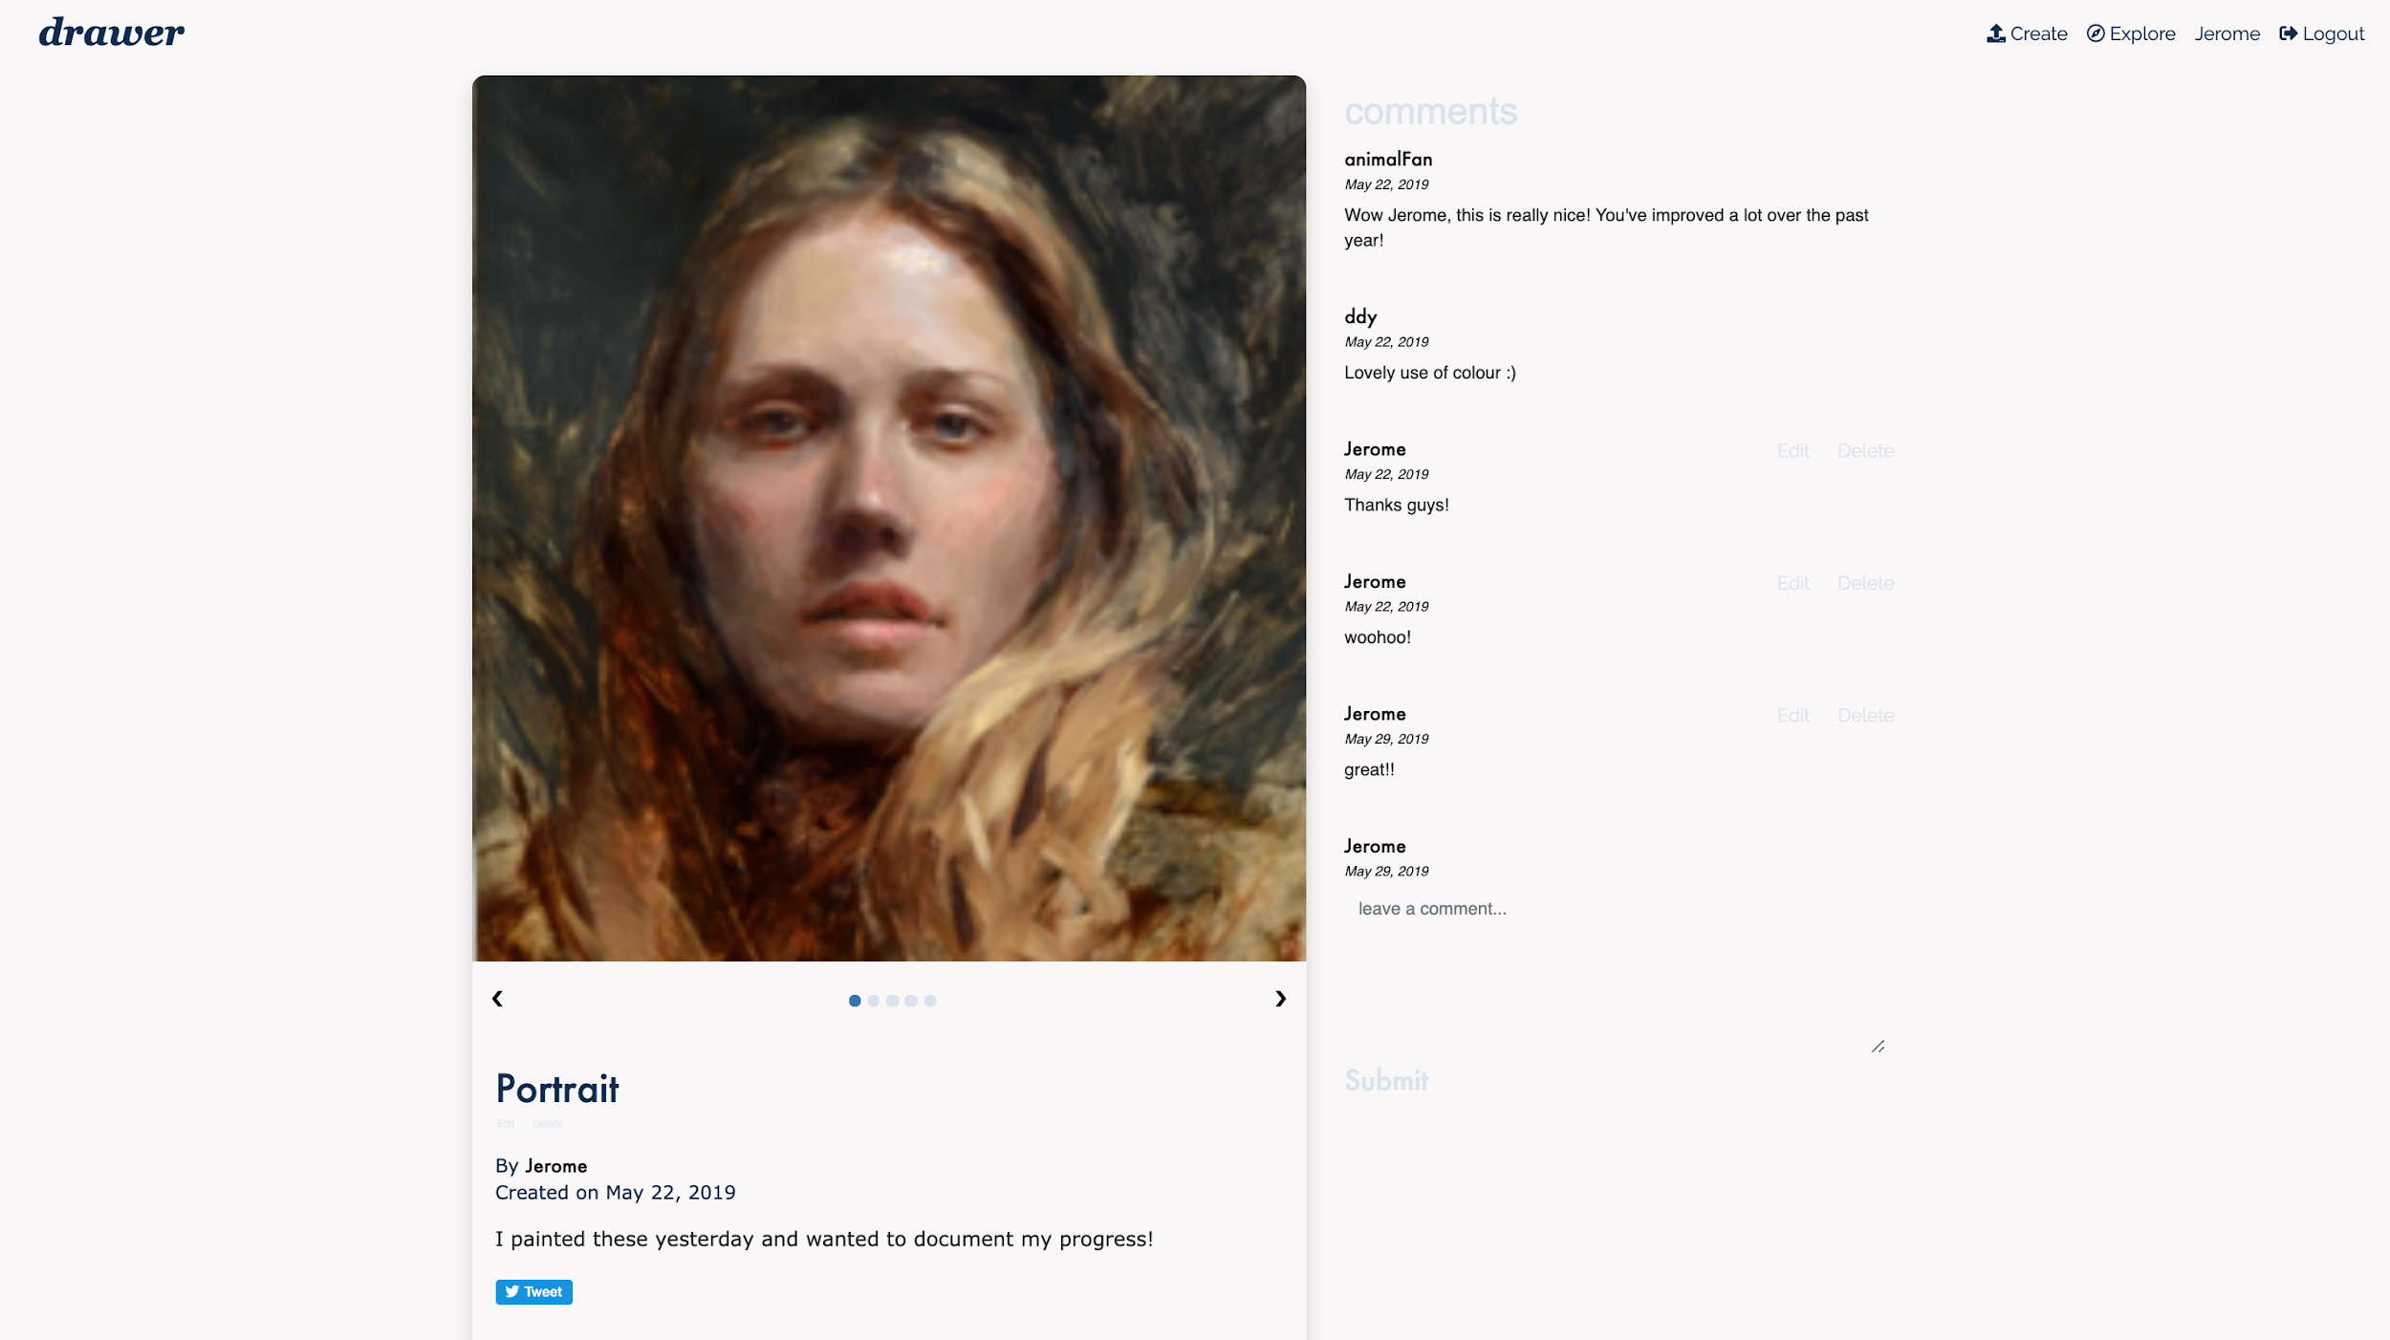

Each artwork uploaded to drawer can be viewed up close on the view art page. This page forms the core of drawer’s social mechanic, as it allows users to discuss and give feedback to one another by leaving comments. From this page, users can also view both the final artwork and a series of photos depicting its making-of process, as well as a description written by the artist about their thoughts and thinking behind the piece. This page also contains references to the twitter and facebook APIs, encouraging users to share the artwork (and also drawer) on social media.

**File upload and storage**

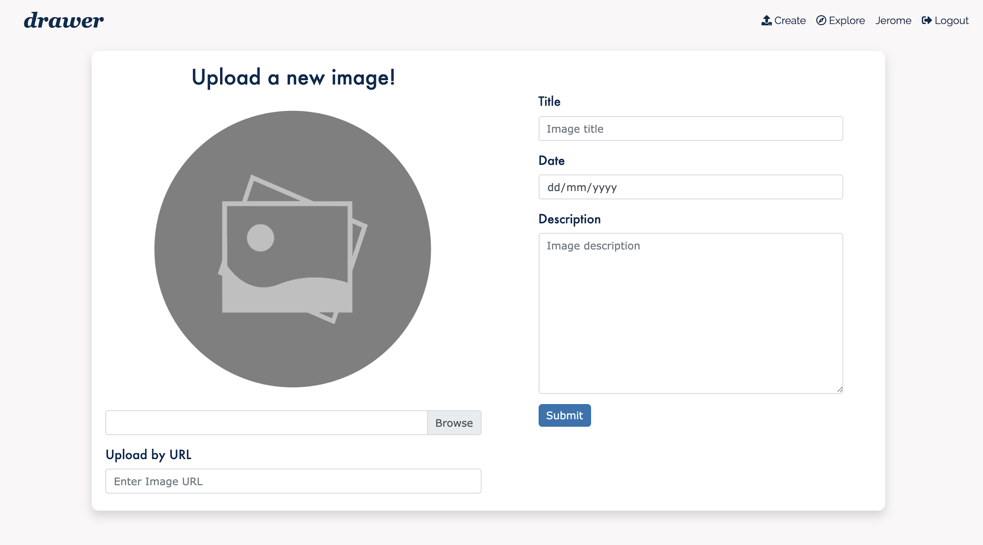

Users can upload their own artworks from the upload page, as well as add a title, set the date that the artwork was completed (which is not necessarily the same as the upload date), and write a short description for their work. To upload an artwork, they can either choose a local file from their device, or upload using a url from another website. The url upload feature was originally intended for just debugging, but we decided to keep it because it makes it easy for users to re-upload works that they might be storing on another website as well.

**System Architecture**

**Component diagram**

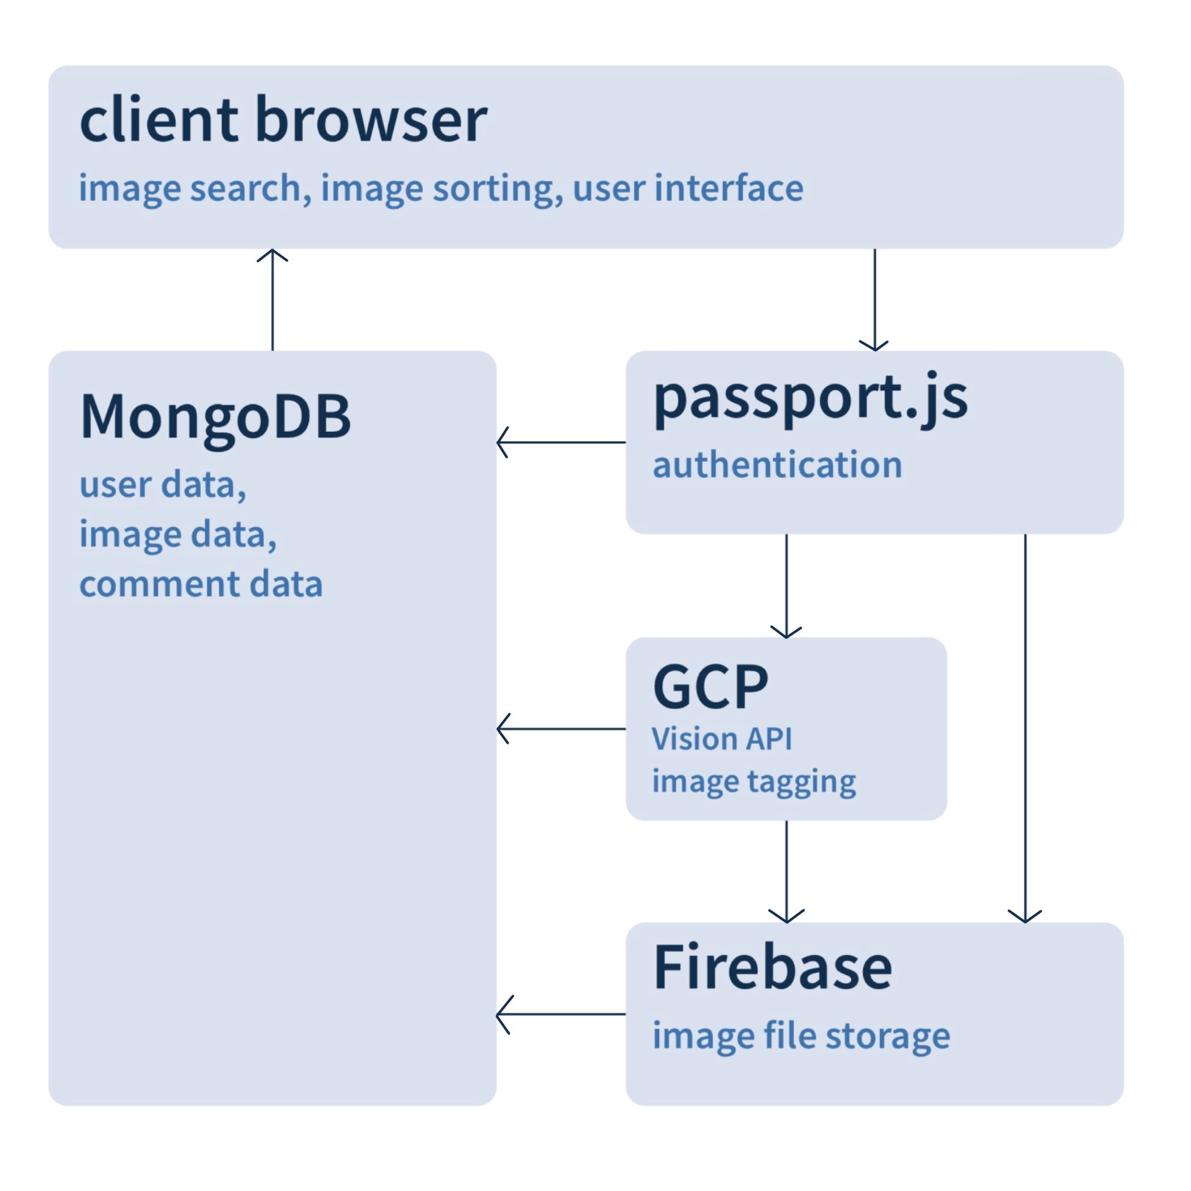

This diagram depicts how our various technologies are tied together. Functions such as sorting and search are managed at the client level. When a user uploads a photo, authentication is managed by passport.js, and the image first passed through GCP for image tagging and Firebase for file storage before being sent to MongoDB as a Firebase link. GET requests including comments, user data and image data are all pulled straight from MongoDB.

**Database**

14. System architecture - mongoDB, schemas

15. System architecture - firebase

16. System architecture - cloud vision

17. Discussion - how are final solution solves the problem that we set out to solve

18. Discussion - what we could do better next time

19. Conclusions